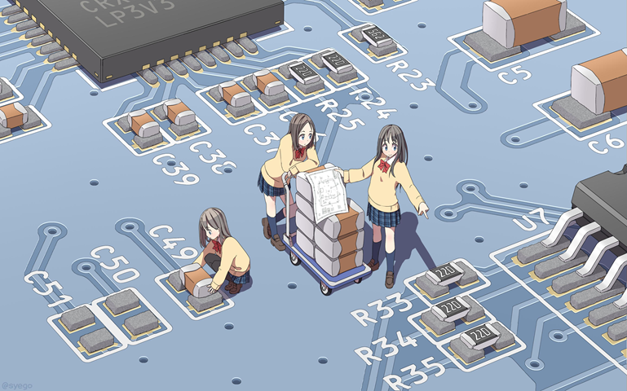

**AWS Lab #7**

**By Diego Santos**

**Intro**

Today we’ll be starting to use the Amazon DynamoDB

**Screenshots**

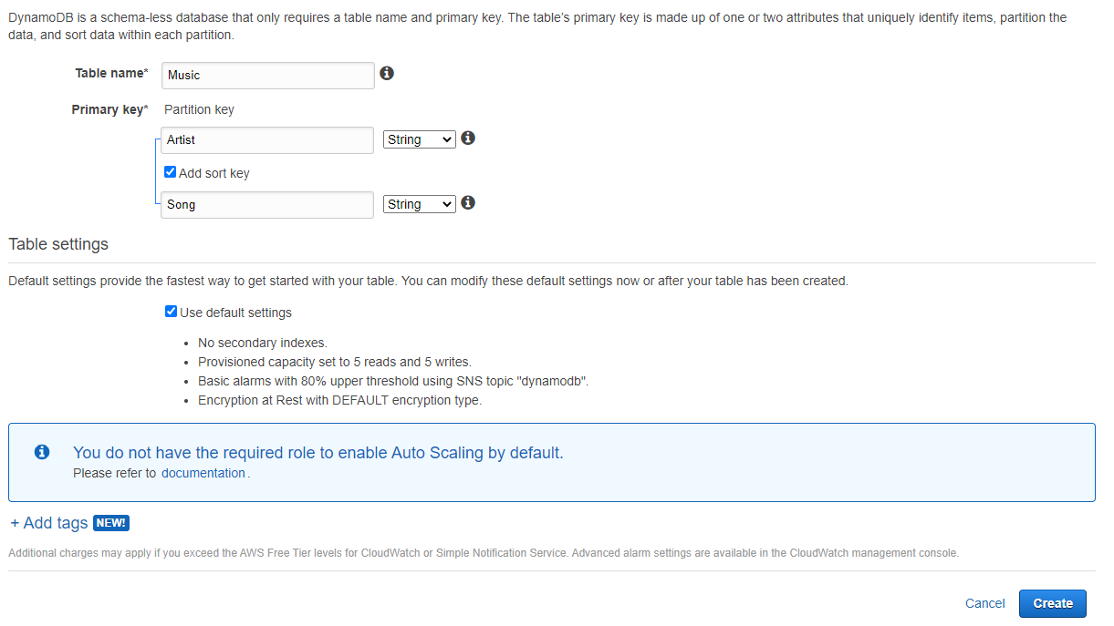

(Creating DB)

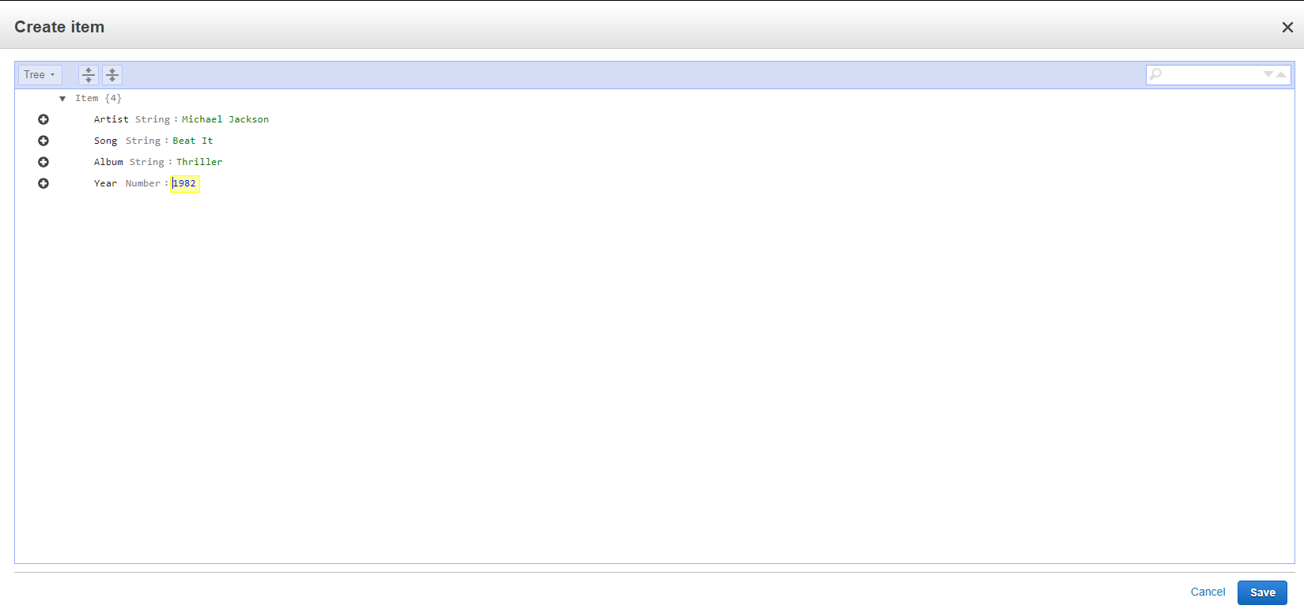

(Creating Item)

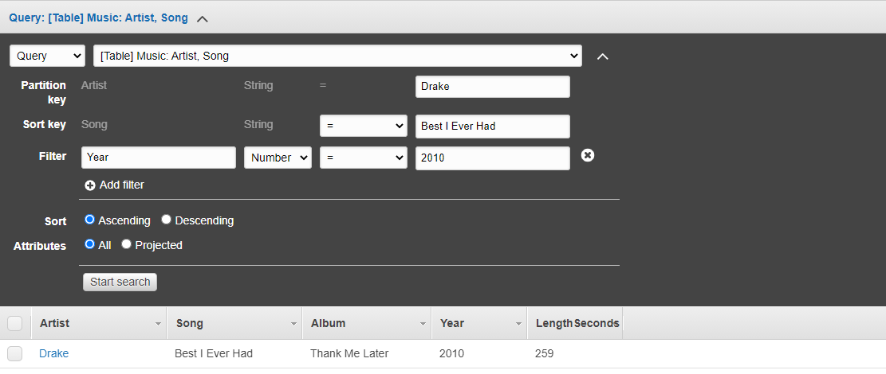

(Creating a query)

**Problems**

I ran into no problems while setting up this lab